**Name: Ayush Vaze**

**Roll No: TE A 76**

**Seminar Title: Smart City using Artificial Intelligence.**

**Abstract:**

The growth of urban areas has led to a significant increase in traffic congestion, impacting both quality of life and economic efficiency. Traditional traffic management systems usually struggle to manage the traffic controls. Aiming that reducing the traffic congestion and making the city smarter by improving the quality of life using Artificial Intelligence and Machine Learning Models. This paper introduces the use of sensors and cameras with computer vision technique. Smart signals with good cameras with advanced sensors and communication capabilities, can collect real-time data on traffic flow and environmental conditions. Machine learning models can be trained on historical traffic data to predict future trends and peak traffic hours, enabling proactive adjustments to signal timings. The system also prioritizes emergency vehicles and public transportation when necessary, ensuring efficient movement across critical routes. The paper demonstrates a significant improvement in traffic flow and reduction in wait times at intersections, contributing to more efficient and environmentally friendly urban mobility. Implementing this solution in cities could lead to faster travel times and a decrease in traffic-related emissions. Furthermore, smart signals can integrate with other smart city infrastructure, such as connected vehicles and intelligent transportation systems, to facilitate seamless and efficient traffic management. In conclusion, the integration of AI and ML-powered smart signals into smart city traffic management systems offers a promising solution to address the challenges of urban congestion.

**Objective:**

To design and implement an AI-powered Smart Traffic Signal System with the help of machine leanring alsorithms and openCV which will aim at optimizing traffic flow and reducing congestion. These system will use real-time data analysis and predictive machine leanring algorithms to efficiently manage traffic conditions and provide a solution for future smart city infrastructure.

**Motivation:**

As the population is increasing, the number of vehicles are also increasing leading to more traffic congestion. To minimize traffic, smart traffic signals can be used with Artificial Intelligence technology and Machine Learning algorithms. This system can dynamically adjust the signals according to live traffic conditions using cameras.

**Flowchart Diagram:**

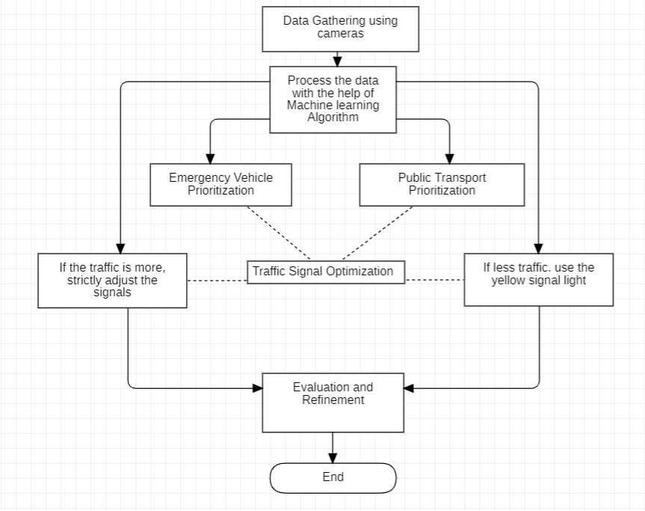

1. **Data Collection:**
   * **Sensors and Cameras:** Collection of real-time data including traffic data and environmental data with the help of sensors and cameras.
2. **Data Pre-processing:**
   * **Cleaning:** Remove noise or errors from the collected data.
   * **Feature Extraction:** Extract relevant features from the data (e.g., traffic density, average speed).
3. **Machine Learning Model Training:**
   * **Historical Data:** Training machine learning models on historical and past traffic data.
   * **Prediction:** Forecast future traffic trends and crowrded hours.
4. **Signal Optimization:**
   * **Algorithms:** Built an machine learning algorithms for optimizing traffic signal timings based on live information.
   * **Adaptation:** Adjust signal timings dynamically to minimize congestion.
5. **Public Transportation Prioritization:**
   * **Detection:** Detect public transportation vehicles (e.g., buses).
   * **Priority:** Give priority to public transportation vehicles during peak hours.
6. **Evaluation and Refinement:**
   * **Metrics:** Evaluate the system's performance using metrics like traffic flow, wait times, and emissions.
   * **Improvement:** Continuously refine the system based on evaluation results.

**Conclusion:**

A smart traffic signal system using AI in the development of smart cities represents a significant step forward in improving urban mobility and reducing traffic congestion. By using AI algorithms, machine learning, and real-time data analytics, these software systems can optimize traffic flow and minimize pollution caused by vehicles. The system adapt dynamically to changing traffic conditions, leading to more efficient and improving overall quality of life in the city.